**Page Layout**

# This menu is used to manage the content before printing the page.

It means

**Themes: -** where theme option apply on the Illustration means shape such as rectangle, circle, oval etc.

**Page setup**: - Page setup is used before print command we need to set the page size, margin, Number of the copy, etc.

**Scale to Fit:** - Combined the content into single page or multiple:

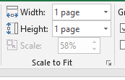

Above diagram show the content in single page.

**Arrange:** - It is used to arrange the Diagram such as send backward, Bring forward etc. These options active when we create any diagrams such as oval, circle, rectangle etc.

Select an object then we can used the send backward….

**Selection Pan: -** It is show the diagram name there we can easily pic that object

**Sheet Options**: - gridline heading both can set the view and print option. It is also given in View menu

# Page setup: -

* Type of Margins:

1. **Last Custom Setting**
2. **Normal**
3. **Wide**
4. **Narrow**

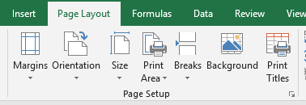

## Orientation

## Size: It is used to set the Paper size which we want to print on paper.

According to paper size we select that option

## Print Area: Print area is used to print the content of specific area form work sheet.

Select data (specific area)->Page layout menu-> Print area-> set Print area

Now we can given the Print command using ctrl+p

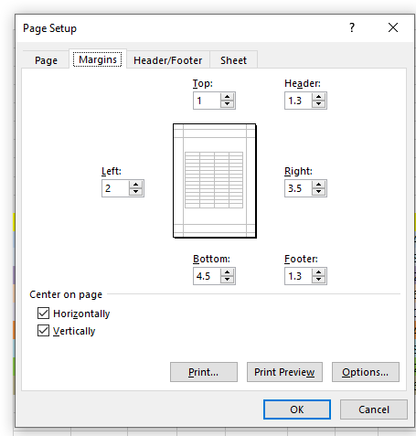

Now your printer start printing if printer is connected from your computer and also attached paper

## Breaks

## Background

## Print Titles

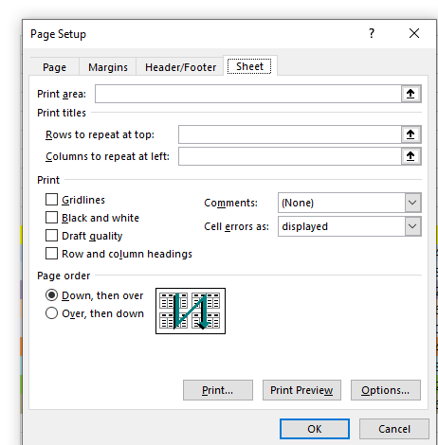

**Print the text/data at the centre of the page from the current sheet of the data**

**Such as given below: -**

